UNITED FASHION

Fashion Weekend Skopje
March 29 – April 01, 2019

Click or tap here to enter text. (brand name or designer name)
Application form
Deadline: December 12, 2018
OVERALL INFORMATION
Enterprise
Company name: Click or tap here to enter text.
Legal form (if applicable): Click or tap here to enter text.
Date of constitution: Click or tap here to enter text.
Business number (if applicable): Click or tap here to enter text.
Website: Click or tap here to enter text.
Facebook: Click or tap here to enter text.
Instagram: Click or tap here to enter text.
Supported by (which partner) Click or tap here to enter text.

Bank Account
IBAN: Click or tap here to enter text.
BIC: Click or tap here to enter text.

Head office address
Street and number: Click or tap here to enter text.
Zip code & city: Click or tap here to enter text.
Country: Click or tap here to enter text.
Phone number: Click or tap here to enter text.

Operational office address (if applicable)
Street and number: Click or tap here to enter text.
Zip code & city: Click or tap here to enter text.
Country: Click or tap here to enter text.
Phone number: Click or tap here to enter text.

Do you have operational offices?
☐Yes ☐No

Contact person for the follow up of the application
Name and surname: Click or tap here to enter text.
Function: Click or tap here to enter text.
Phone number: Click or tap here to enter text.
Mobile number: Click or tap here to enter text.
Email address: Click or tap here to enter text.

ACTIVITIES
Describe the products likely to be exported (you can also attach a presentation file):
Click or tap here to enter text.

Describe your interest for both activities: Workshop and Production:
Click or tap here to enter text.

Describe your motivation for the United Fashion project and the UF programme at Fashion Weekend Skopje
Click or tap here to enter text.

ACCOUNTING DATA
Turnover (excluding VAT) € last financial year:
Click or tap here to enter text.

SALES INFO
E-shop Click or tap here to enter text.
Sale points Click or tap here to enter text.

EXPORT FIGURES
Total amount of your export for the last two years preceding this request:
Year 1 (2016)€ Click or tap here to enter text.
Year 2 (2017)€ Click or tap here to enter text.

Specify your five most important export markets over the last 2 years.
Click or tap here to enter text.

STRATEGIC PLAN FOR EXPORT
Explain how this initiative in Skopje for which you are applying is part of your company's interest/strategic export plan:
Click or tap here to enter text.

________________

A project of

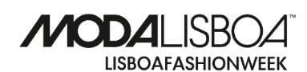

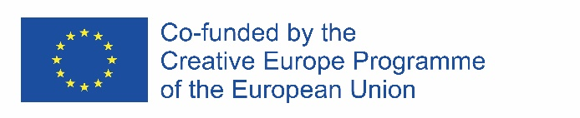
Supported by

